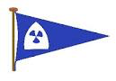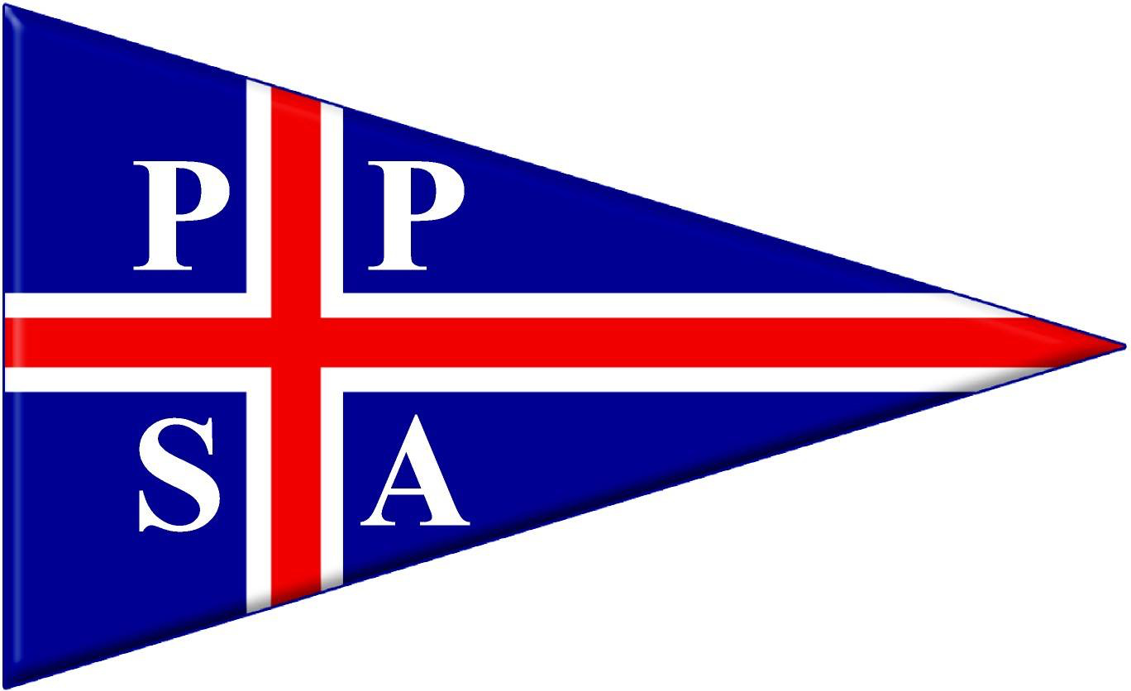

2026 Chris Moyse Memorial
Pursuit Race
(Hosted by Plym Yacht Club)

Notice of Race

Notice of Race
Organising Authority (OA) –Port of Plymouth Sailing Association and Plym Yacht Club

RULES
  - Racing will be governed by the ‘Rules’ as defined in the Racing Rules of Sailing (RRS), National and Local Prescriptions and the 2026 YTC Handicap Policy and Procedures

1.3 Plymouth is a Naval/ Commercial Port, shipping movements can be frequent and must have priority. Boats, at all times, must keep clear of ships leaving or entering the port and obey instructions from the Race Committee where avoiding action is necessary. Failure to obey Race Committee instructions may be treated as misconduct.
  - The Post-Race Penalty and RYA Hearing/Arbitration of the RYA Rules and Disputes procedures will be available. This is the preferred method of resolving disputes. See the official website for details. See: https://www.rya.org.uk/racing/rules/rules-disputes

ELIGIBILITY AND ENTRY
  - Boats entering the Chris Moyse Memorial Pursuit Race should have a valid 2026 YTC Handicap. A YTC Handicap Rating can be applied for at https://rorcrating.com/ryaytc
  - Late entries wishing to enter the Chris Moyse Memorial Pursuit Race without a 2026 rating can apply for a temporary rating to secretary@ppsa.org.uk giving boat type, sail no and whether a spinnaker will be carried.
  - Entries should be made online at https://www.ppsa.org.uk/yacht-regatta

ENTRY FEES:
  - No entry fee payable.
- SCHEDULE
4.1
DATE | TIME | ACTIVITY
Friday 17th July 2026 | 1830 | Chris Moyse Pursuit Race, scheduled first start time
- RACES AND COURSES
  - There will be ONE single pursuit race. Start times will be communicated to competitors at least 24 hours prior to the first start.
- SAILING INSTRUCTIONS
6.1 The Sailing Instructions will be available on the Regatta website at https://www.ppsa.org.uk/yacht-regatta by 1000 on Wednesday 1st July 2026.
- RADIO COMMUNICATIONS
  - All boats shall carry a VHF Radio. Course details and start signals will be communicated to entrants via VHF Ch M1 (37).
- COURSES
8.1 The course will be round navigational or laid marks as detailed in the Sailing Instructions.
- PRIZES
  - The winner will be awarded the Chris Moyse Memorial Trophy. Other prizes may be given.
- RISK STATEMENT
  - Rule 3 of the Racing Rules of Sailing states: “The responsibility for a boat’s decision to participate in a race or to continue racing is hers alone”.
  - Sailing is by its nature an unpredictable sport and therefore inherently involves an element of risk. By taking part in the event, each competitor agrees and acknowledges that they;
10.2a are aware of the inherent element of risk involved in the sport and accept responsibility for the exposure of themselves, their crew and their boat to such inherent risk whilst taking part in the event;
10.2b they are responsible for the safety of themselves, their crew, their boat, and their other property whether afloat of ashore;
10.2c they accept responsibility for any injury, damage or loss to the extent caused by their own actions and omissions;
10.2d their boat is in good order, equipped to sail in the event and they are fit to participate;
10.2e provision of a race management team, patrol boats and other officials and volunteers by the event organiser does not relieve them of their own responsibilities;
10.2f provision of patrol boat cover is limited to such assistance, particularly in extreme weather conditions, as can be practically provided in the circumstances.
  - The fact that the race committee may conduct inspections of a boat does not reduce the responsibilities of each competitor set out in this notice of race.
- INSURANCE
  - Each participating boat is required to hold adequate insurance in the sum of £3,000,000.
- FURTHER INFORMATION.
12.1 For further information contact secretary@ppsa.org.uk

