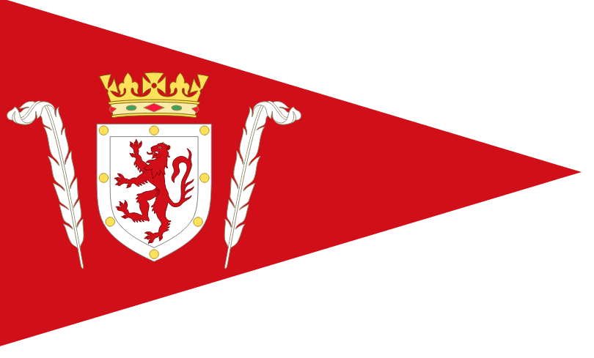

PPSA PLYMOUTH

CRUISER REGATTA 2026
YTC
White Sail
Bilge Keel

Notice of Race

Hosted by Saltash Sailing Club and Tamar River Sailing Club

Notice of Race
Organising Authorities (OA) – Port of Plymouth Sailing Association, Saltash Sailing Club and Tamar River Sailing Club

HW 0931, 5.3m

RULES
  - Racing will be governed by the ‘Rules’ as defined in the Racing Rules of Sailing (RRS), Prescriptions and the following, as appropriate:
    - The 2026 RYA YTC Handicap Policy and Procedures.
    - Class Rules for One Designs including their crew limits (if any).

  - Where there is conflict between this Notice of Race and the Sailing Instructions, the Sailing Instructions shall prevail except that neither shall change nor alter a class rule. This changes Rule 63.7.

- Plymouth is a Naval/ Commercial Port, shipping movements can be frequent and must have priority. Boats, at all times, must keep clear of ships leaving or entering the port and obey instructions from the Race Committee where avoiding action is necessary. Failure to obey Race Committee instructions may be treated as misconduct.
  - The Post-Race Penalty and RYA Hearing/Arbitration of the RYA Rules and Disputes procedures will be available. This is the preferred method of resolving disputes. See the official website for details. See: https://www.rya.org.uk/racing/rules/rules-disputes

ELIGIBILITY AND ENTRY
  - Classes will be offered for YTC, White Sail and Bilge Keel. All classes will use YTC handicaps. Depending on the number of entries, the YTC class may be split into YTC A and YTC B
  - YTC handicaps can be applied for at https://rorcrating.com/ryaytc Boats wishing to enter and are unsure of their dimensions may be able to get those from this website: https://sailboatdata.com/

  - Eligible boats should enter online at https://www.ppsa.org.uk/yacht-regatta
3.4 Entries should be received by Sunday 12th July 2026. Entries received after this date will be considered to be late entries and will be accepted at the discretion of the Race Committee.

ENTRY FEES:

YTC
White Sail
Bilge Keel
All Classes | £20

SCHEDULE

DATE | TIME | ACTIVITY
Saturday 19th July | 1030 | First Start TRSC  I race scheduled all classes
 | 1300 | Results and Lunch at TRSC
 | 1430 | First Start SSC  2 races scheduled YTC  I race scheduled White Sail & Bilge Keel
 | 1700+ | Prize Giving & Social at SSC

5. RACES
5.1 YTC Class: Twos race scheduled for Saturday a.m. with start and finish at Tamar River Sailing Club and the 2 races scheduled for Saturday p.m with start and finish at Saltash Sailing Club.
5.2 White Sail & Bilge Keel Classes: one race scheduled for Saturday a.m. with start and finish at Tamar River Sailing Club and 1 race scheduled p.m with start and finish at Saltash Sailing Club.
5.3 There will be no discards.

SAILING INSTRUCTIONS
  - The Sailing Instructions will be available on the Regatta website at https://www.ppsa.org.uk/yacht-regatta no later than Saturday 11th July 2025.

VENUE
  - Racing will take place in the Rivers Tamar and Lynher from Saltash Sailing Club (SSC) and Tamar River Sailing Clubs (TRSC). See Appendix A.

THE COURSES
  - Courses and location will be class dependent and will be Round the Cans (RTC) using the buoys and navigational marks detailed in the Sailing Instructions.

SCORING
  - The Low Point System of Appendix A will apply.
  - All classes will be scored using RYA YTC handicaps as shown in the RYA YTC 2025 listings (https://rorcrating.com/ryaytc/ryaytclistings ).

BERTHING
  - Berthing will be available on the pontoons at both SSC and TRSC together with mooring facilities. A water taxi service will be available throughout the regatta from both SSC and TRSC.

RADIO COMMUNICATION
  - All boats shall carry a suitable VHF radio. Except in an emergency, a boat shall neither make radio transmissions while racing nor receive radio communications not available to all boats. This restriction also applies to mobile telephones.

PRIZES
  - Overall class prizes/trophies will be awarded to each class. A Yacht of the Regatta Prize will be awarded. Other prizes may be awarded.

RISK STATEMENT
  - Rule 3 of the Racing Rules of Sailing states: “The responsibility for a boat’s decision to participate in a race or to continue racing is hers alone”.
  - Sailing is by its nature an unpredictable sport and therefore inherently involves an element of risk. By taking part in the event, each competitor agrees and acknowledges that they;
13.2a are aware of the inherent element of risk involved in the sport and accept responsibility for the exposure of themselves, their crew and their boat to such inherent risk whilst taking part in the event;
13.2b they are responsible for the safety of themselves, their crew, their boat, and their other property whether afloat of ashore;
13.2c they accept responsibility for any injury, damage or loss to the extent caused by their own actions and omissions;
13.2d their boat is in good order, equipped to sail in the event and they are fit to participate;
13.2e provision of a race management team, patrol boats and other officials and volunteers by the event organiser does not relieve them of their own responsibilities;
13.2f provision of patrol boat cover is limited to such assistance, particularly in extreme weather conditions, as can be practically provided in the circumstances.
13.3 The fact that the race committee may conduct inspections of a boat does not reduce the responsibilities of each competitor set out in this notice of race.
14. INSURANCE
14.1 Each participating boat is required to hold adequate insurance and in particular to hold insurance against third party claims in the sum of at least £3,000,000. It is the duty of each boat owner to have his boat adequately insured against any risk, including civil responsibility to third parties and to ensure that such insurance remains valid for the entirety of the regatta.
15. FURTHER INFORMATION
15.1 For further information please contact the event coordinator on
Moondragon75t@hotmail.com

Appendix A - Venue

