PPSA Plymouth Yacht Regatta
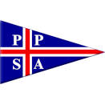
2026 J/24 Plymouth Regatta
Saturday 18th - Sunday 19th July 2026
The Organizing Authority is the Port of Plymouth Sailing Association (PPSA)
In conjunction with Plym Yacht Club
SAILING INSTRUCTIONS

1 RULES
1.1 See NoR 1.1-1.6
1.7 Where there is conflict between this Notice of Race and the Sailing Instructions, the Sailing Instructions shall prevail except that neither shall change nor alter a class rule. This changes Rule 63.5(c) 2

2 CHANGES TO SAILING INSTRUCTIONS
2.1 Any changes to the Sailing Instructions will be posted in the competitor WhatsApp group before 0800 on the day they will take effect (see SI 3.1). They may be repeated via VHF up to 5 minutes before the first warning signal of the day, except that any change to the schedule of races will be posted by 20:00 on the day before it will take effect.

3 COMMUNICATIONS WITH COMPETITORS
3.1 Notices to competitors will be posted on the official notice board at https://www.ppsa.org.uk/j24 , during the event communications will only be made on PPSA Yacht Regatta WhatsApp group ( all competitors will be added to this group) and VHF.
3.2 On the water the race committee intends to monitor and communicate on Ch 72, Ch 77 will be used if Ch 72 is unusable.
The following communications may be made by the race committee on Ch 72/77 : time checks; race area; location of committee vessel; signals; courses; change of courses; shortening; post ponement; abandonment.
All competitors shall monitor Ch 72 &/or 77 for these courtesy communications.
Signals, flags and boards displayed on the committee vessel are the primary means of conducting the racing, any lack of VHF communication to the fleet will not be grounds for redress under RRS 61.1a.
4 CODE OF CONDUCT
4.1 Competitors and support persons shall comply with reasonable requests from race officials.
5 SIGNALS MADE ASHORE

DOES NOT APPLY

6 SCHEDULE OF RACES
Date | Max no of races | First warning signal not earlier than:
Saturday 18thJuly | 4 | 10.55  Fun bottle race after last race, to Saltash SC finish line
Sunday 19th July | 3 | 10.25  The warning signal for the last race on Sunday will not be made after 1400

7 CLASS FLAGS

7.1 The J24 Class flag (blue insignia on a white background) shall be used as per RRS 26.

8 RACING AREA

8.1 The racing area is Plymouth Sound and the area South of Plymouth Breakwater as shown in SI Appendix 1.

9 COURSES

9.1 The diagram in SI Appendix 2 shows the windward/leeward courses LA & WA to be used.

9.2 No later than the warning signal, the race committee signal vessel shall display the approximate compass bearing of the first leg.

9.3 No later than the warning signal, the race committee signal vessel shall display the course number - ( e.g. LA2)

10 MARKS
Mark | Type/Shape | Colour
1 | Cone | Yellow - PYC
1a | Cone | Yellow - PYC
2s & 2p | Tetrahedral | Red - Sail GP
Change mark 1 | Cone | Orange - PYC
SP Starting mark port end | Orange Danbuoy | Orange flag
SS Starting mark starboard end | Committee Vessel (CV) | S/Y “ TBA ”
FP Finishing mark port end | Committee Vessel (CV) | S/Y “TBA ”
FS Finish mark starboard end | Orange Danbuoy | Blue flag

10.2 If one of the marks (1, 1p, 2s or 2p) is missing the remaining mark should be rounded to port. This changes RRS 34.

11 OBSTRUCTIONS

11.1 Boats, whilst sailing to and from the racing area, should not enter the Mooring Areas ( as shown in Appx 4) located north of Mountbatten peninsula and south of the Plym navigation channel, unless they are avoiding commercial shipping .

11.2 Shipping traffic routes in Cattewater are shown in SI Appendix 4.

11.3 The diagram in SI Appendix 3 shows the moving exclusion zone (MEZ) in place for designated vessels, (submarines, large tidally constrained warships, auxillaries and support vessels). All boats are required under the terms of the Dockyard Port of Plymouth Order 2020, not to enter the MEZ. This prohibited zone, ranks as an obstruction to sea room under RRS.

12 THE START

12.1 Races will be started using RRS 26.

12.2 To alert boats that a race will begin soon the orange starting line flag will be displayed with one sound five minutes before the warning signal.

12.3 The starting line will be between a mast displaying an orange flag on the committee vessel and an orange dan buoy with an orange flag, (see 10.1 above).

12.4 A boat that does not start within 4 minutes after her starting signal will be scored Did Not Start without a hearing. This changes RRS 63.1, A5.1 and A5.2.

12.5 In addition to the procedures in RRS 29.1, the Race Committee may announce on VHF that one or more boats were over the line, but not sooner than 1 minute after the start. Competitors are reminded that it is their responsibility to ensure that they have started correctly. Failure to make or receive such transmissions is not grounds for redress under RRS 61.1(a). This changes RRS29.1

13 CHANGE OF A LEG OF THE COURSE

13.1 While boats are racing the race committee may change the windward leg of the course, the race committee will lay a new change mark 1, (see 10.1 above) as per RRS33. The race committee will remove the original marks as soon as practicable.
If mark 1 is changed, mark 1a is no longer a mark of the course
When a new mark is laid the original marks will be removed as soon as practicable. When in a subsequent change the change mark is replaced, it will be replaced by the original mark.

13.2 Mark moves of less than 200m may be made without signaling the change, this changes RRS33.

13.3 When Flag “F” is displayed with repeated sound signals at the windward mark (1or 1a), boats shall proceed directly to the finish.

14 THE FINISH

14.1 The finishing line is between the mast on the committee vessel displaying a blue flag, and a dan buoy with a blue flag.

14.2 The course may be shortened by the RC at the windward mark – see SI 13.3, or at the Finishing
Line. In this event the committee vessel shall display flag S with two sound signals prior to the
lead boat approaching marks 2p/2s, in addition, a Race Committee boat may be positioned
adjacent to mark 2 displaying K flag all boats shall then complete the lap they are sailing and after
passing mark 2p left to port proceed to the Finishing Line where they will be deemed to have
finished.
This applies to ALL boats regardless of whether they are on the same lap as the leading boat. This changes and is additional to RRS 32.2.

14.3 After some boats have finished the race committee may record other boats as deemed to have finished before they cross the finish line to save time whether or not they were expected to complete the course within the time limit.

A RC boat displaying flag W will proceed from the finish line towards the previous mark, make a sound signal and verbally hail the boat that they have been recorded as deemed to have finished.

The RC may record boats as deemed as finishing as per this instruction at more than one leg of the course and will if necessary, continue the back sweep around the course until all boats are recorded. When a boat finishes in accordance with this instruction she shall be given a finishing place after all boats which had previously finished and in the sequential order in the direction from the finish line.

If another race is scheduled boats that have been hailed as per this instruction are required to proceed immediately to the starting area. This changes RRS 28, 32.1, 32.2, 35 and Appendix 2. This action will be at the absolute discretion of the RO and this decision shall be final and shall not be grounds for redress under RRS 61.1a.

15 PENALTIES

15.1 See NoR 14

16 TIME LIMITS AND TARGET TIMES

16.1 The target time for races is 40 minutes. Failure to meet the target time will not be grounds for
redress. This changes RRS 61.4(b)1

16.2 Boats failing to finish within 30 minutes after the first boat sails the course and finishes, and not subsequently retiring, penalised or given redress, will be scored TLE (Time Limited Expired) without a hearing. A boat scored TLE shall be scored two more points than the number of boats that have finished within the time limit. This changes RRS 35, 60.5(b)3, A4 and A5.1, A5.2 and A10.

16.3 If no boat has passed the first mark within 30 minutes, the race will be abandoned.

17 HEARING REQUESTS

17.1 The protest time limit is 90 minutes after the last boat finishes the last race of the day or 90 minutes after the time that the Race Committee signals that racing is abandoned for the day, whichever is the later. The time will be posted on the official notice board.

17.2 Hearing Request forms are available from the Race Committee. Hearing Requests and Requests for Redress or reopening shall be delivered to the Race Committee within the appropriate protest time limit.

17.3 Notices will be posted no later than 30 minutes after the protest time limit to inform competitors of hearings in which they are parties or named as witnesses. Hearings will be held at Saltash SC. beginning as soon as possible, after posting.

17.4 On the last scheduled day of racing, a request for redress based on a protest committee decision shall be delivered no later than 30 minutes after the decision was posted. This changes RRS 61.2.

18 SCORING
18.1 As per the Notice of Race.

19 SAFETY REGULATIONS
19.1 [DP] A boat that retires from a race shall notify the race committee at the first reasonable opportunity.

20 REPLACEMENT OF CREW OR EQUIPMENT

20.1 Crew replacements are limited to those allowed by NoR 1.7.1 and class rule H.4.3. The Race Committee shall approve a crew substitution during the event in case of illness or emergency.

20.2 Even if replacement or crew substitution is allowed, the number of crew shall not change during the event.

20.3 Substitution of damaged or lost equipment will not be allowed unless authorised in writing by the Race Committee. Requests for substitution shall be made to the Race Committee at the first reasonable opportunity, which may be after the race.

21 EQUIPMENT AND MEASUREMENT CHECKS

21.1 A boat or equipment may be inspected at any time for compliance with the class rules, notice of race and sailing instructions.

22,23,24 NOT IN USE

25 TRASH DISPOSAL
25.1 Trash may be placed aboard official or support person vessels.

26 NOT IN USE
27 HAUL OUT RESTRICTIONS

27.1 See NoR 19

28 DIVING EQUIPMENT AND PLASTIC POOLS

28.1 See NoR 20

29 PRIZES

27.1 Prizegiving as detailed in the Notice of Race at PYH on Sunday 19th July

30 RISK STATEMENT

30.1 See NoR 22

31 INSURANCE
31.1 see NoR 23

Appendix 1 - Course Areas
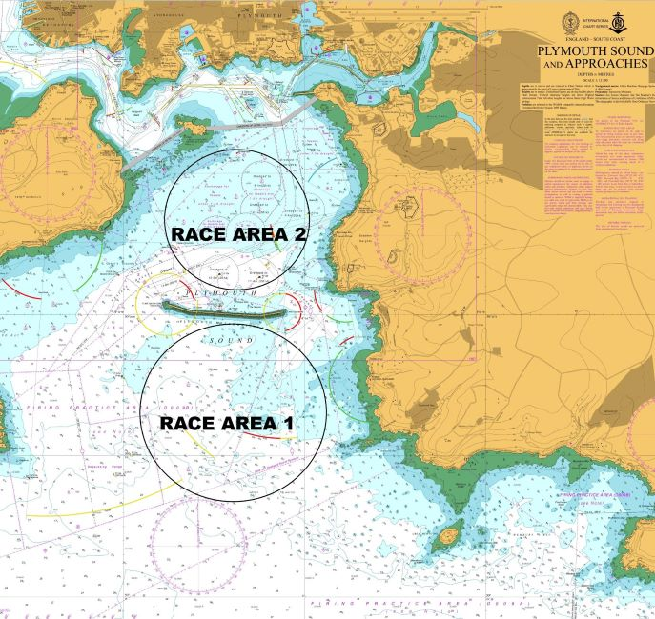

© British Crown Copyright 2024. All rights reserved.

NOT TO BE USED FOR NAVIGATION

Appendix 2 - Courses
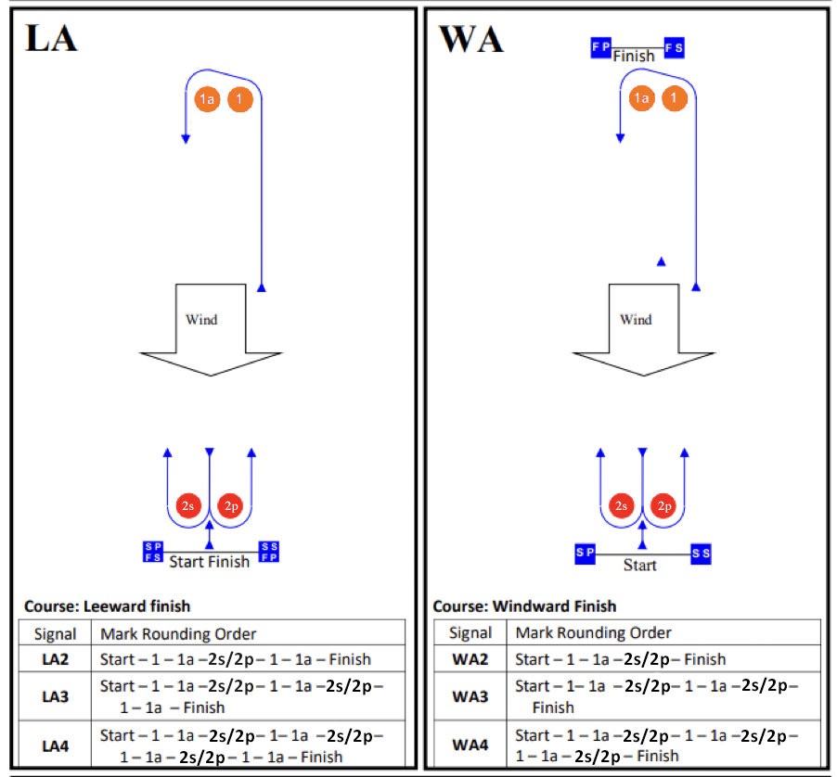

Appendix 3
Moving Exclusion Zone

LNTM 012/24
PLYMOUTH LOCAL NOTICE TO MARINERS 012/24
GENERAL DIRECTION
MOVING EXCLUSION ZONES (MEZ) FOR DESIGNATED VESSELS
1. This notice is a General Direction from the King’s Harbour Master Plymouth (KHM) pursuant to the Dockyard Port of Plymouth Order 2020.
2. The Dockyard Port of Plymouth Order 2020 includes the provision for KHM to establish a moving exclusion zone (MEZ) around specified vessels for the protection of that vessel and to ensure its safe passage.
3. A MEZ can be established for large tidally constrained warships, auxiliaries and support vessels and all submarine movements within the Dockyard Port. The exclusion zone will extend 250m ahead of and 100m abeam and astern of the vessel.
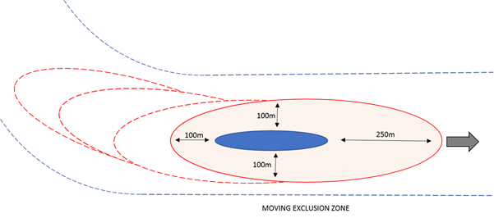
4. With the exception of submarines, a vessel to which a MEZ applies shall display:
a. Between sunrise and sunset, two black diamond shapes vertically disposed.
b. Between sunset and sunrise, in restricted visibility and at other times when deemed necessary, two all-round flashing red lights at the masthead horizontally disposed. If a vessel is not fitted with these lights, 3 all-round red lights vertically disposed may be displayed in their place.
5. For a submarine movement the presence of the MEZ will be indicated by the escorting tugs displaying:
a. A black cylinder by day.
b. 3 all-round red lights vertically disposed by night or in restricted visibility.
6. When a MEZ is in effect:
a. The zone must not be entered by any vessel underway with the exception of MoD vessels and vessels supporting the move.
b. Any vessel alongside, at anchor, at a buoy or mooring within the MEZ shall not get underway until the entitled vessel/submarine has passed.
Monday 01 Jan 2024, R Giles, King's Harbour Master, Plymouth

Appendix 4
Cattewater shipping routes and obstructions
