

Armada Sails Dinghy Traveller Series 2026
PPSA DINGHY REGATTA

One down and four to go. The CHALLENGE is on!
Having lost the Saturday to strong winds, in a constant 16knt breeze on the Sunday the Whitfield duo dominated the field at the PPSA Dinghy Regatta, although Jake Brian (ILCA4) is ready to pounce should they make a mistake, with Adam Watson (RS600) also hovering in the wings. There are some BIG names who won’t be happy trailing in their wake and looking to reverse their fortunes at the next event.
The message to the early leaders is LOOK BEHIND YOU!!, but then that is what you will all be hoping to do as you join in the next event.
We hope to see you at the next event.

See the results on the PPSA Events page

SCHEDULE OF NEXT RACES

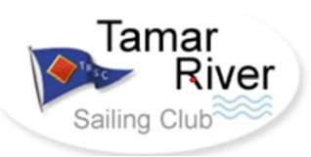
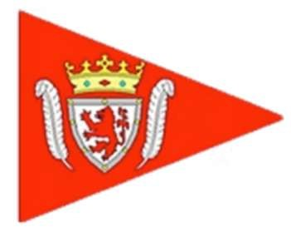
SSC Saturday 27th June TRSC Saturday 25th July

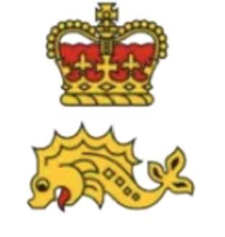
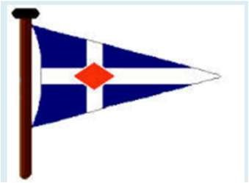
TMSC Sunday 23rd Aug RWYC Saturday 17th October
(note change of date)

Free to enter and open to all dinghies with a PY number. Just enter any one or all of the ports host clubs events for automatic entry into the series.
Fleets consist of:
Fast – 1019 and below
Medium – 1020 – 1169
Slow/Novice – 1170 and above
Any fleet that can raise 5 or more boats will be considered for their own results

Organizing authorities: Royal Western Yacht Club, Saltash Sailing Club, Tamar River Sailing Club, Hooe Point Sailing Club, Plym Yacht Club and Torpoint Mosquito Sailing Club

Series results and overall awards for the Series will be presented at the end of year
PPSA Prize giving

